The Title of Your Paper
List the author names here (e.g. Joan Doe, PhD)
Type the author affiliations here, including the country (e.g. State University in Strelsau, Ruritania)
Abstract. Start your abstract here…
Keywords: First keyword, second keyword…
1 First section of your paper (Section style)
The first paragraph after a heading is not indented (Body Text style). Headings don’t need to be numbered.
Other paragraphs are indented (Body Text Indented style). Avoid empty lines, headings provide enough white space after the previous paragraph.
1.1 A subsection (Subsection style)
Some text.
1.1.1 A subsubsection (Sub-Subsection style)
Avoid using more than 3 heading levels.
2 In-text citations
Citations follow the APA style (Mrázová, 2021). According to Mrázová (2021), citation introduced by a phrase that includes the author’s name followed by the year of publication in parentheses can also be used.
When there’s two authors to the cited paper, list them both and use the ampersand in the parentheses (Hale & Pace, 1998).
When there’s more than two authors, list only the first author followed by “et al.”, even in the first reference (Crosby et al., 1999).
For direct quotation from a work, “include the page number for the reference preceded by ‘p.’ for a single page and ‘pp.’ for a span of multiple pages, with the page numbers separated by an en dash” (Author, 2021, pp. 119–120).
3 Advanced formatting
Keep your paper’s formatting as simple as possible. Avoid section–subsection headings immediately following one another.
3.1 Block quotes
Longer quotations (40 words or longer) should use the form of block quotes. Choose paragraph style with smaller font size (Block Quote style) to make them distinct. Do not make any empty lines before or after the quote, the style is already spaced. The reference in parentheses comes after the final punctuation. (Author, 2021, p. 115)
3.2 Lists
When listing items:
- For unordered lists, use Bulleted List style.
- Avoid multilevel lists.
  - Three levels is definitely too much.

The same goes for numbered lists:
- Use Numbered List style.
- Avoid multilevel lists.
- Proceed to the next paragraph or section.
3.3 Tables and figures
Tables and figures are headed by a number followed by a clear, descriptive title or caption. They are numbered in the order they appear in the text, tables and figures separately.
Table 1. Staff of the Royal Library in Strelsau, Ruritania (Caption Tab-Fig style)
(Table Text style) | 2020 | 2021
Total employees | 40 | 39
Services & Acquisition | 31 | 28
Education & Research | 3 | 3
Management | 4 | 5
Maintenance | 2 | 2
IT | 0 | 1

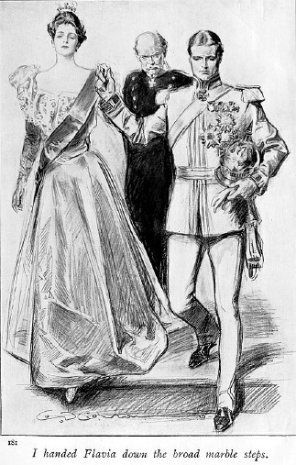Figure 1. King Rudolph V of Ruritania and Princess Flavia

References
Use Reference List style.
Author, N. N. (2021). Axioms. Eternity Publishing.
Crosby, D., Stills, S., Nash, G., & Young, N. (1999). Looking Forward [Album]. Reprise Records.
Hale, G., & Pace, N. (1998, July 1). Fictitious On-Line Article. Fictitious Website. https://never.gona.get/this-song-out-of-your-head
Langdon, R. (2002). Symbolism in Renaissance Art. Library Reports, 15(3), 26–32.
Mrázová, M. (2021). Citation References. Moravskoslezská vědecká knihovna v Ostravě.
Neveu, S., & Langdon, R. (2003). The Ultimate Code and How to Break It. Cryptology in Forensic Research, 6(1), 89–112. https://doi.org/12.3456/1234567890123
About the author(s)
A short description of the authors’ field of expertise, education and affiliations.
Type the corresponding author’s e-mail address here (e.g. theauthor@example.edu).

